Reading a Source Citation

Uncovering your source information for a source card can be a confusing task. Each database provides the information, but they vary as to where it will be found in the document. The most common place is at the end of the document in what is called the Source Citation.

Gale/ OVRC
Gale Group typically presents the information this way. Below is a Gale Group article from the Opposing Viewpoints Resource Center. Note the different elements required on a source card from an On-line subscription database. Click on the comment on the right and it will highlight the information you are looking for:

Source Citation: Steffen, Lloyd. "Executions Are Only Just If They Meet Stringent Moral Conditions." At Issue: The Ethics of Capital Punishment. Ed. Nick Fisanick. San Diego: Greenhaven Press, 2004. Opposing Viewpoints Resource Center. Thomson Gale. Ocean Township High School. 11 Dec. 2007 <http://find.galegroup.com/ovrc/infomark.do?&contentSet=GSRC&type=retrieve&tabID=T010&prodId=OVRC&docId=EJ3010313202&source=gale&srcprod=OVRC&userGroupName=oakh32455&version=1.0>.

- If a group or person(s) name(s) do not appear before the article title, then there is No Author.
Below is a different setup for source information from EBSCOhost’s Points of View database. Note the same items that are required for a source card from a subscription database.

- In the sample you are in EBSCOhost’s Points of View database, as indicated by the acronym pov that follows the “.com/” of the URL. Therefore you can stop after the pov.
- The retrieval date is the date you first get the article.
- EBSCOhost is the online service title.
Database Title
Publish Date
Journal Title
Article Title
SIRS Researcher/ Pro-Con
Author
Page #
SIRS source information is listed at the beginning and ends of articles. Be careful not to use the format they list for MLA at the end of each article without checking the most current MLA handbook requirements. Currency of requirements may not match!

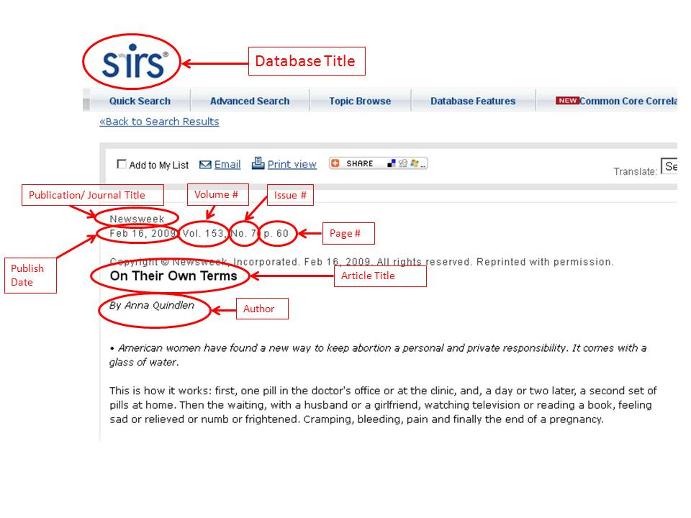

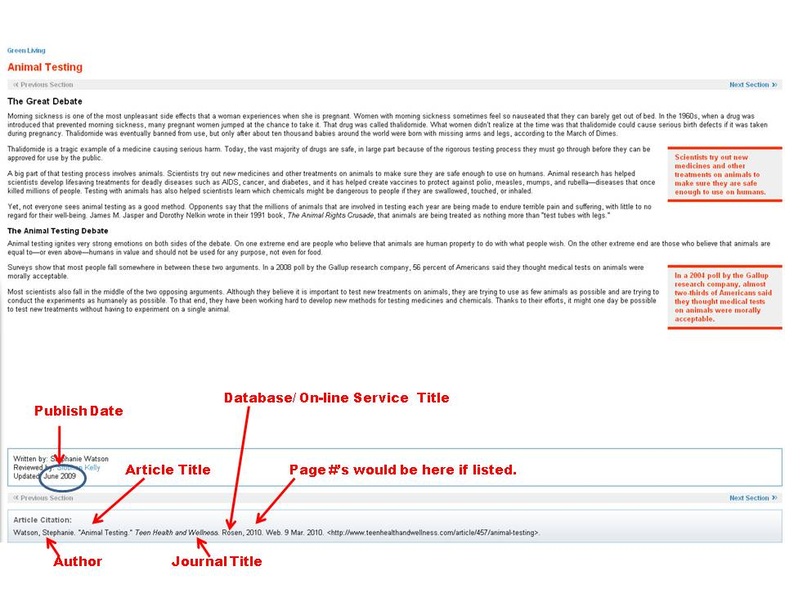
Teen Health and Wellness
Source information is listed at the bottom of the article. Note how Teen Health and Wellness is the Journal title for the article and Rosenis Company credited as the Database since it is the publisher of this on-line service.
Facts on File

This database looks much like Gale’s citations and are at the end of the articles. Some slight variations of the listing order is evident however. See the sample below:

- In the URL, note the database indicator that shows you went to Facts on file, the Science Online database:

http://www.fofweb.com/Science/default.asp?ItemID=WE40

- In the Citation information, click on the comment on the right and it will highlight the information you are looking for:

Citation Information
Record Citation: Barber, Nigel. "Endangered Species Act, 1973." Encyclopedia of Ethics in Science and Technology. Facts On File, Inc., 2002. Science Online. Facts On File, Inc. http://www.fofweb.com/activelink2.asp?ItemID=WE40&SID=5&iPin= ethics0133&SingleRecord=True (accessed December 12, 2007).
Web Page
A web page requires different source information. Use the Landmark site at http://citationmachine.net and click on MLA and Web Page on Non-Print sources to see what a source card requires. You will find that the bibliography entry will need the Author, Page Title, Site Title, Publishing or Last Revision Date, Organization, Date Accessed, and URL.
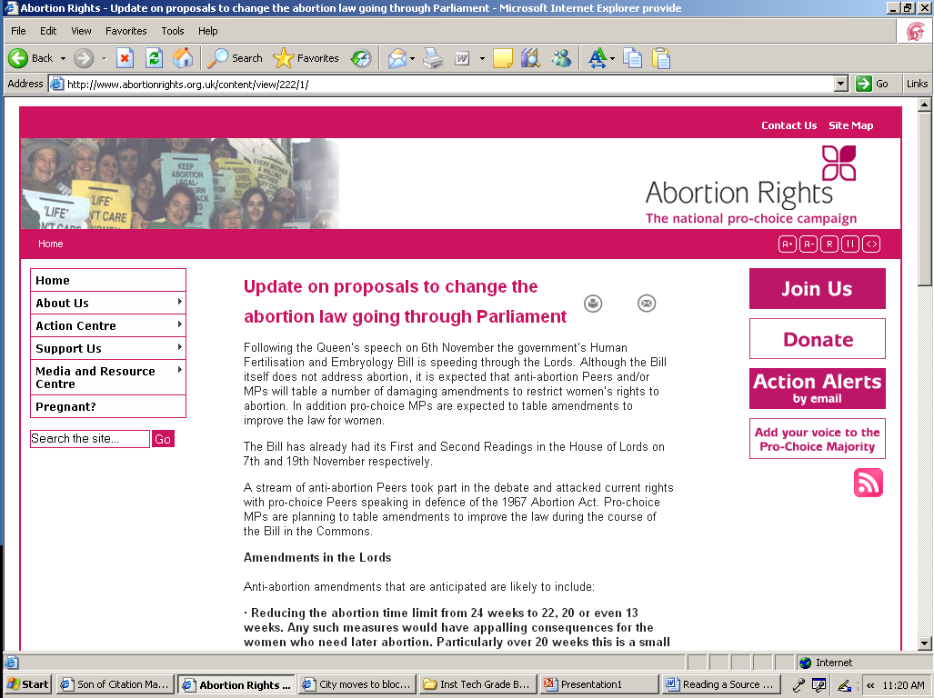
Only give the URL when a reasonable web search of the author and/ or title and topic would not return the instructor to the site.
Internet Journal or Magazine Article
Publishing or Last Revision Date
Organization
Site Title
Page Title
Again, use the Landmark site at http://citationmachine.net and click on MLA and Internet Journal or Magazine Article to see what a source card requires. You will find that the bibliography entry will need the Author, Article Title, Publication Title, Volume # (or Issue # or Identification #), Publication Date, Page Numbers, Date Accessed, Article URL.

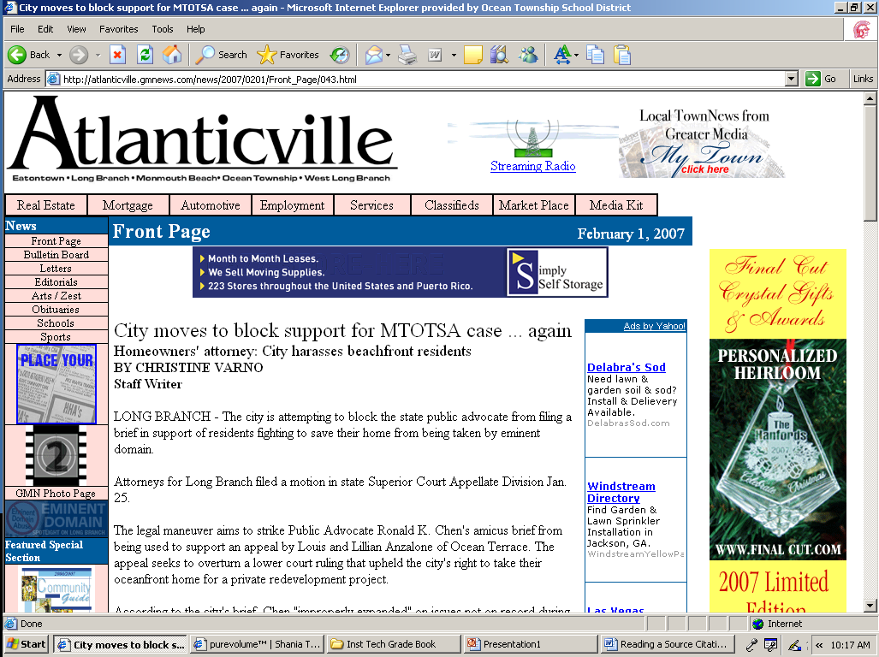
In this case, no page #’s are given
Author
Article Title
Publication Date
Publication Title
Give entire URL

Blooms Literary Reference Center
Author
Title of Publication
Title of Database
URL
Article Title

